

**SPECIFICATIONS** HS-CSFM-982

. . . . . . . . . . . . . . . . . . . . . . . . . . . . . . . . . . . . . . . . . . . . . . . . . . . . . . . . . . . . . . . . . . . . . . . . . . . . . . . . . . . . . . . . . . . . . .

**Circuit Sensor® Flow Meter**

**Unrestricted lengths of straight piping**

**Required to maintain calibrated accuracy®**

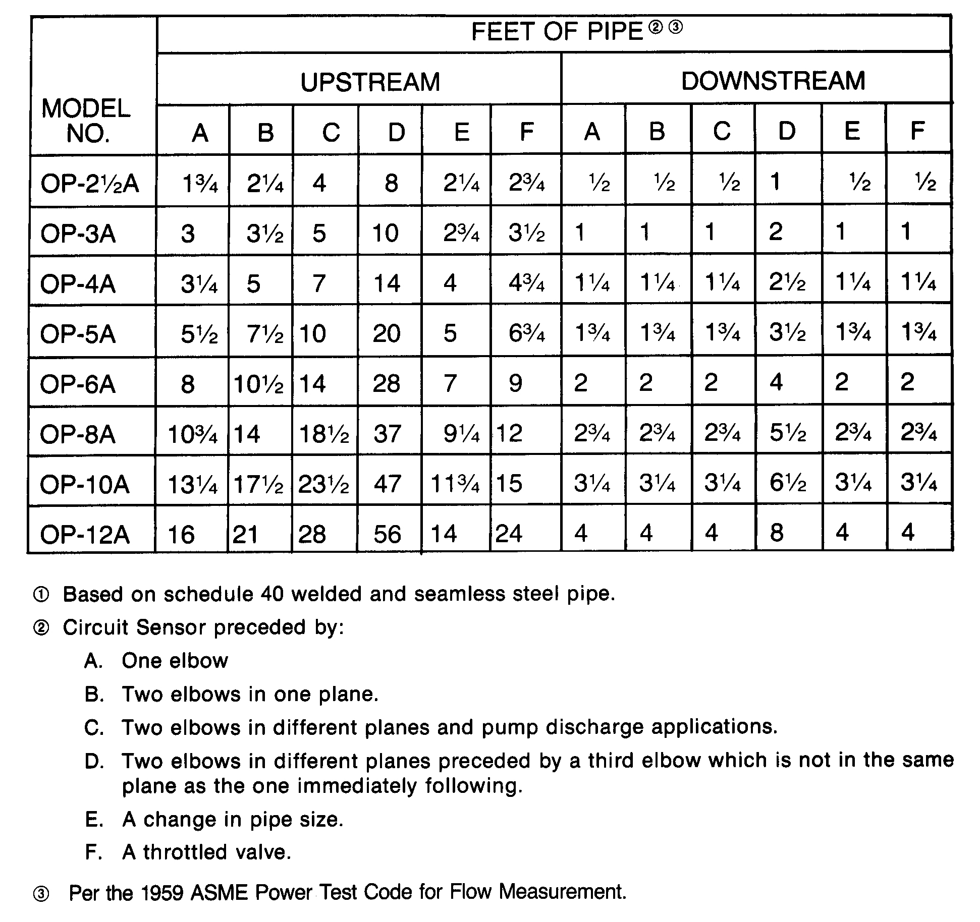

[www.bellgossett.com](http://www.bellgossett.com/)

Bell & Gossett is a trademark of Xylem Inc. or one of its subsidiaries.

© 2016 Xylem Inc. HS-CSFM-982 September 1982